**LAB # 5**

**Start, Sleep and Stop methods of multithreading**

**OBJECTIVE:**

Understanding concurrency by implementing start, sleep and stop thread functions.

**LAB TASK:**

By using start, stop and sleep methods of threading, print alphabets of English from A-Z. (Hint: use math.random method for getting random numbers and then convert them into characters, print 26 characters under run method loop with fluctuating visualization through sleep method).

**SOL:**

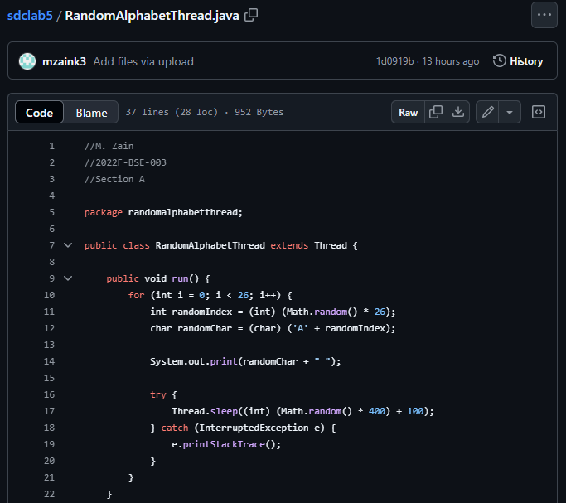

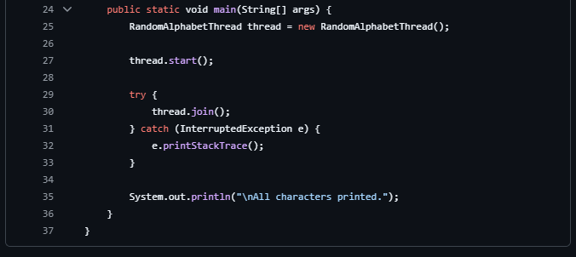

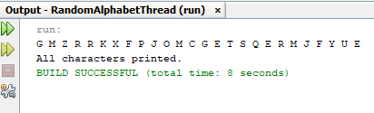

**CODE BREAKDOWN:**

1. **start() Method**:

The start() method is called in the **main** method to begin the thread's execution.

1. **run() Method**:

The run() method contains the logic that the thread will execute. It loops 26 times to print a random letter and then pauses for a random time using **sleep().**

1. **sleep() Method**:

**Thread.sleep()** is used to pause the thread for a random time between 100ms and 500ms after printing each character.

1. **stop() Method**:

The **stop()** method is **not used** in the code because it's deprecated and unsafe (because it pre-maturely stops a Thread). The thread naturally finishes after completing the 26 iterations of the loop.